***Exercise***

Mel and Fred bake bagels. They both make bagels that have an inner radius of 0.5 *in*. and an outer radius of 2.5 *in*. Mel plans to increase the volume of his bagels by increasing the outer radius by 20% (leaving the inner radius unchanged). Fred plans to increase the volume of the bagels by decreasing the inner radius by 20% (leaving the outer radius unchanged).

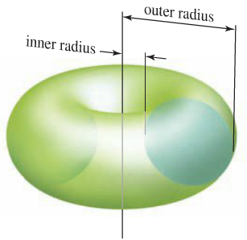

1. Whose new bagels will have the greater volume?
2. Does this result depend on the size of the original bagels? Explain.
3. If *R* and *r* increase at the same rate, does the volume of the bagel increase, decrease, or remain constant?
4. If *R* and *r* decrease at the same rate, does the volume of the bagel increase, decrease, or remain

***Solution***

1. Let ***R*** be the outer radius and ***r*** be the inner radius

The radius of the circle: 

The center of the circle: 















|  |  |
| --- | --- |
|  |  |















Mel by decreasing the inner radius by 20% :











Fred by decreasing the outer radius by 20% :











Since , then 



1. So, the bagel increases the outer radius is bigger than the inner bagel, independent of the size of the original bagels.
2. 





If *R* & *r* increase at the same rate, then  is a constant and  always increases.

∴ the volume is increasing.

1. If *R* & *r* decrease at the same rate, then  is a constant and  always decreases.

∴ the volume is decreasing.







